# Name : Shrinivas Hatyalikar

# Div: TY-B (B2)

# Roll No: 26

Q) Implementation of Tower Of Hanoi

**Part 1:**  
Input: n (denotes the number of disks)  
Output: Assuming that the disks are placed on peg A, print the steps / moves on how to move them to peg C, by following the rules discussed.

**Code:**

#include <stdio.h>

int move_counter = 0;

void move(int n, char source_tower, char destination_tower, char intermediate_tower) {

    if (n > 0) {

        move(n - 1, source_tower, intermediate_tower, destination_tower);

        printf("Move top disc from %c to %c\n", source_tower, destination_tower);

        move_counter++;

        move(n - 1, intermediate_tower, destination_tower, source_tower);

    }

}

int main() {

    int n=0;

    printf("Enter number of disks: ");

    scanf("%d",&n);

    move(n, 'A', 'B', 'C');

    printf("Total moves: %d\n", move_counter);

    return 0;

}

**Output:**

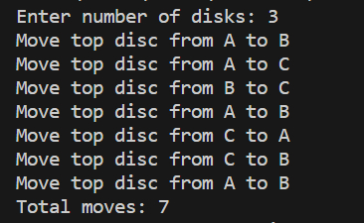

**Part 2:**  
Input: n (denotes the number of disks), k (denotes the move / step number, starts with 1, max value of k is 2^(n)-2

Output: which disk will be moved after the kth move. Assume that disks are numbered from 0 to n-1, 0 being the smallest one.

**Code:**

#include <stdio.h>

#include <math.h>

// Function to find the disk number moved after k moves.

int findDiskNumber(int totalDisks, long long moves) {

    if (totalDisks == 1) {

        return 0; // There is only one disk, so it's disk 0.

    }

    long long mid = pow(2, totalDisks - 1);

    if (moves < mid) {

        return findDiskNumber(totalDisks - 1, moves);

    } else if (moves == mid) {

        return totalDisks - 1; // The largest disk is being moved (disk totalDisks - 1).

    } else {

        return findDiskNumber(totalDisks - 1, moves - mid);

    }

}

int main() {

    int totalDisks;

    long long moves;

    printf("Enter the number of disks (n): ");

    scanf("%d", &totalDisks);

    printf("Enter the move number (k): ");

    scanf("%lld", &moves);

    if (moves < 1 || moves >= pow(2, totalDisks)) {

        printf("Invalid move number. The valid range for k is [1, 2^n-1].\n");

    } else {

        int diskNumber = findDiskNumber(totalDisks, moves+1);

        printf("Disk number moved after %lld moves: %d\n", moves, diskNumber);

    }

    return 0;

}

**Output:**

